**Oats Porridge**

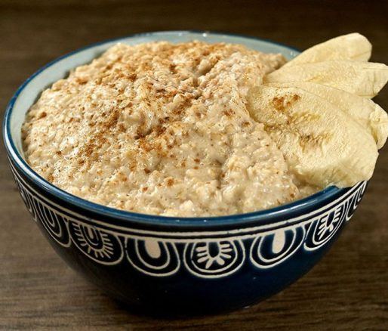

**INGREDIENTS**

10 cup(s) water

1/2 cup(s) evaporated milk

1 whole cinnamon leaf

1/2 cup(s) raisins optional

1 1/4 teaspoon(s) salt

3 cup(s) oats

1 nutmeg grated

1 teaspoon(s) cinnamon powder

1 1/2 teaspoon(s) vanilla essence

1 1/2 cup(s) sweetened condensed milk

**METHOD**

1. Put eight cups of water to boil. Add evaporated milk, cinnamon leaf, raisins and salt.
2. Combine oats with nutmeg and cinnamon powder. Add vanilla essence to the remaining 2 cups water and add to the oats mixture; mix well.
3. Add oats mixture to the boiling liquid and stir until the porridge comes to a boil. Reduce heat and cook for about 5 minutes.
4. Mix in the sweetened condensed milk.